**Calculating Cognitive Load of a Virtual Reality System Using Eye-Tracking Data**

**Abstract**

The goal is to acquire a user’s cognitive load(CL) in a VR intelligent framework, a technique for user subjective load evaluation dependent on the eye movement data is put forward. Using an eye movement tracking instrument in association with VR device, eye movement data were collected. Among all the eye movement parameters, utilising the Fixation frequency, Fixation duration, Saccade amplitude, Saccade duration and P as the autonomous factors, and Channel, Subjective CL and Objective CL as the reliant factors, a CL assessment model was made dependent on probabilistic neural system. The model was verified by comparing the results from the model with the general subjective load information. The model established in this study based on probabilistic neural network showed absolute error of the channel in range of 4.62% - 16.69%. The relative mean square error is 11.25%–37.71%. The average absolute error and Relative Root Mean Squared Error for the whole dataset is 5.75%, 12.524% respectively. This shows that the model is highly practicable.

**Introduction**

The CL is the proportion of assignment unpredictability to the psychological capacity needed by the person to finish the work[1]. The work can be depicted as the task which has the contains working memory and load. Any mental workload tremendously affects the person’s capacity to carry out assignments[2]. It is a very important human factor straightforwardly identified with the effectiveness of the framework activity, workplace wellbeing, and creative productivity in various fields[3]. In the in-vehicle data framework (IVIS), the modern and unpredictable arrangement of different methods of information may activate the driver’s subjective load, bringing about operational errors and auto collisions[4,5]. Along these lines, analysts have been directing quantitative analysis on the CL, mostly estimating the working memory limit and specific consideration component changes in two phases[6]. Physiological signs, (for example, pulse and respiratory rate), mind action, circulatory strain, skin electrical reaction, student measurement, flickering, and look are viewed as biomarkers for evaluating the CL[7,8]. There is a data structure that can viably measure the mental workload in online shopping, limit the person’s data to control the purchase[9]. Contrasts in individual subjective capacity and how to upgrade the mental workload influence human intellectual control, which prompts various disclosures of physiological changes as CL, and eye development innovation can impartially quantify the insight of individuals[10]. The examination of eye-following information gives quantitative proof to the difference in the interface format and the impact on individual’s understanding and CL[11]. Numerous scientists use eye development conduct information to acquire the user’s conduct propensities and intrigue contrast to pass judgment on the user’s CL[12-14]. Asan et al. contemplated the physiological file related to the eye development following innovation and CL[15]. These examinations have concentrated on the utilisation of techniques to evaluate the users subjective load.

Notwithstanding investigating the effect of users’ physiological markers on CL, a few scientists have likewise utilised AI to anticipate the quantitative mental workload. The K-NN (k-NearestNeighbour) calculation was utilized to figure the intellectual load of the person. It depended on, for example, an adjustment in the oxygen in blood substance[16,17]. Different examinations have indicated artificial neural classifiers and systems dependent on the outstanding task at hand of the EEG (Electroencephalogram) power range progressively[18-21]. Likewise, artificial neural systems, accumulation techniques, and comparable methodologies have been used to anticipate the user’s subjective load. The motivation behind this paper is to acquire real & precise user’s mental workload esteems in the computer-generated simulation (VR) intuitive framework. The eye development test was utilised, where fixation frequency, obsession length, saccade plentifulness, saccade span and P was gotten by the eye development instrument. A mental workload assessment model was built dependent on PNN. It measures the CL then gives a hypothetical premise to the plan and improvement of the resulting computer-generated reality intuitive framework.

A dataset of 80 rows consisting of different eye movement data of different people under different cases was considered. The data was normalised. After finding the ideal number of clusters, K-Means Clustering was done. Then, the appropriate channel was identified for each cluster. Then CL was calculated using a probabilistic neural network model. The results obtained were good and well within the error limits.

**Related Work**

**Information Integration(Multi-Channel) in the Virtual Reality System**

To take care of the issue of evaluating the subjective load of users in a computer-generated experience intuitive framework and to diminish the trouble of intelligent, intellectual investigation, scarcely any analysts have built a psychological handling model that incorporates contact, hearing and vision[22]. To improve the proficiency of collaboration, a few specialists have likewise settled a reasonable modular model and a framework human-PC model[23]. By re-enacting the procedure of a human mind perception, the paper considers intuitive conduct of computer-generated experience framework from subjective and computational points of view. It at that point develops the intuitive data incorporation model of computer-generated reality, and the last yield esteem is the CL estimation of users, with the end goal that the CL can be measured. To understand the capacities in the intuitive framework, users utilise visual, sound and audio channels to dissect the errand. Data is divided into triple-channel, dual channel, and single-channel. The mental workload of user in the augmented simulation framework would then be able to be evaluated.

**Constructing the Evaluation Model for CL Quality**

The assessment model is based of probabilistic neural network. This model is made up of 3 processing layers. The primary layer(first layer), which helps in the calculation of attribute qualities. The second layer is the secondary layer. It also explains the attributes of mass quantum. The Third or tertiary layer is the evaluation layer. It estimates the value of CL index. In this study, the characteristics of the VR interactive system is estimated with the help of hierarchial partition theory. This VR system for attributes assessment framework model uses the client CL as the quality attributes of a computer generated simulation intelligent framework quality assessment model, finds the quality sub-qualities, lastly builds up the CL quality assessment model of the augmented simulation intuitive framework with the eye movement index file as the estimation file.

**CL Physiological Index on the Basis of Eye Movement Data**

For obtaining the CL of a user, the eye movement index is used explicitly because, during a mental workload, for reflecting the cognitive awareness the eye movement parameters are more important than other behavioural patterns of our body[24]. It is most generally utilised CL figuring technique, eye development innovation depends on fixation frequency, fixation duration, saccade amplitude, saccade duration, P and other trial information to unbiasedly and logically assess the psychological heap of a VR intelligent framework. In this way, this paper picks eye development innovation as the creative way to deal with build up a CL assessment model dependent on the probabilistic neural system.

1. Fixation Frequency

The fixation frequency is relative to the CL of the augmented simulation crossing point framework. The higher the fixation frequency, the bigger the CL is, and the other way around. Accordingly, the fixation frequency is acquainted as a CL record with measure the intellectual heap of family units.

2. Fixation Duration

The more data we convey, the more drawn out our eyes remain fixed, and the more CL we have. Somewhat, this assessment record can be utilised to mirror the intellectual heap of users. This is the reason for use of fixation duration as a parameter for assessment of CL.

3. Saccade Amplitude

Saccade is the quick movement of the eye between fixation points. Thus, the CL of the user is dependent on the saccade amplitude. So, when the Saccade amplitude increases, the CL of the user also increases.

4. Saccade Duration

Higher saccade duration means fixation points are located farther away. This increases the CL. Therefore, the saccade duration is used as an evaluating parameter for the calculation of the CL of users.

5. P

P (Performance) is the score obtained by each participant from NASA-TLX while performing the task for the experiment. It is the score obtained form a total score of 100.

**Methods**

**CL Evaluation Model**

**Theorem 1**: U represents the user’s cognitive domain, and C represents the cognitive domain of cognitive channels, expressed as:

$U=\left[C_{α} C_{β} C_{λ} . . .\right]$ (1)

where each, Cα, Cβ, Cλ, etc., represents a cognitive pathway, and the collection of sample points under the complete influence of each cognitive pathway are termed as B. A collection of cognitive behaviours or sample points of the user is shown below:

$B= \left[b_{1} b_{2} b_{3} . . . b_{s}\right]$ (2)

Where, each bi represents a single cognitive behaviour of users

For the construction of a CL evaluation model, eye movement index parameters are taken as input and the subjective CL is considered as output. This can be visualised from fig 1.

* Input: It refers to the eye movement data such as fixation frequency, Fixation duration, Saccade amplitude, Saccade duration and P. All these eye movement parameters are classified into channel-1(visual channel), channel 2 (visual-tactile channel), channel 3 (visual-auditory channel), and channel 4 (visual-audio-tactile channels).
* Fusion: It refers to the incorporation of the acquired data into the CL model.
* Output: It refers to the final solution obtained after processing of input data. It’s the value of CL quantified by the load evaluation model under a particular channel.

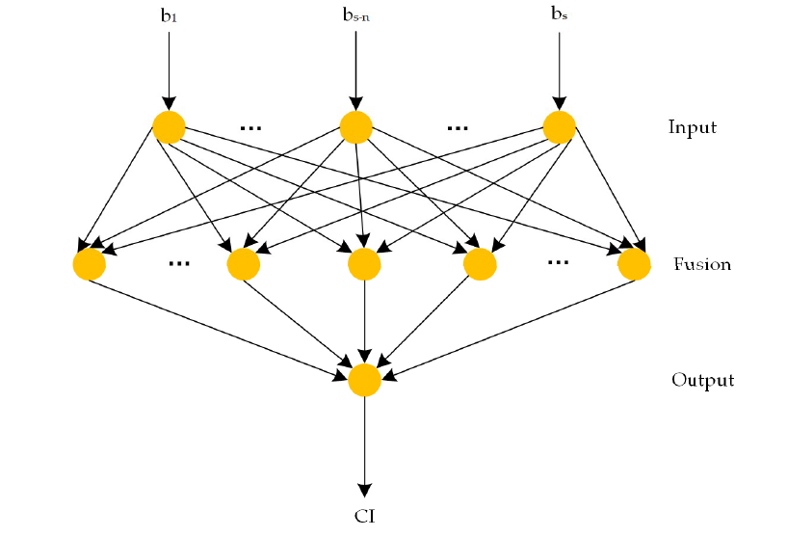

**Fig 1**: Probabilistic neural network model

There are s eye movement indicators and y scheme values. The eye movement matrix indicator data of the scheme is:

$$B^{'}= \left[\begin{matrix}b_{11}' & b_{12}' ⋯ & b_{1s}' \\ b_{21}' & b_{22}' ⋯ & b_{2s}' \\ \begin{matrix}⋮ \\ b_{y1}'\end{matrix} & \begin{matrix}⋮ \\ b_{y2}'…\end{matrix} & \begin{matrix}⋮ \\ b_{ys}'\end{matrix}\end{matrix}\right]$$

The eye movement indicator data is represented by each column of the matrix. The test value is represented by each row. Since the unit of pointer information is extraordinary, it is hard to analyse the information legitimately, so it is essential to standardise the knowledge of every section, play out the direct change of the first data & guide the outcome incentive between 0 & 1. In the event that CL value rises with an increment of any eye movement index, then the transformation function used is given below:

$b_{ip}= \frac{b_{ip}'-min\left\{b_{ip}' |i=1, 2, . . ., s \right\}}{max\left\{b_{ip}' |i=1, 2, . . ., s \right\}-min\left\{b_{ip}' |i=1, 2, . . ., s \right\}}$ (3)

Conversely, the conversion function is

$b_{ip}=\frac{max\left\{b_{ip}' |i=1, 2, . . ., s \right\}-b_{ip}'}{max\left\{b_{ip}' |i=1, 2, . . ., s \right\}-min\left\{b_{ip}' |i=1, 2, . . ., s \right\}}$ (4)

where “min” is the smallest value, and “max” is the largest value of the index data. The matrix B now is:

$B= \left[\begin{matrix}b_{11} & b_{12} ⋯ & b_{1s} \\ b_{21} & b_{22} ⋯ & b_{2s} \\ \begin{matrix}⋮ \\ b_{y1}\end{matrix} & \begin{matrix}⋮ \\ b_{y2}…\end{matrix} & \begin{matrix}⋮ \\ b_{ys}\end{matrix}\end{matrix}\right]$ (5)

We did not have channels. So, to separate different channels, we used K-Means Clustering. The ideal number of clusters were found using Elbow method, which came out to be 4. So, we divided the dataset into four parts - Very High CL, High CL, Medium CL and Low CL. Since, we did not know which clusters belonged to which CL, two parameters which had a high correlation with the CL were chosen. Based on their behaviour, the clusters were defined. The average of the columns for each cluster is used in their respective calculations.

When Zj = [b1j b2j ….. byj]T, Z is the column vector y. We have to find a function so that the MSE can be calculated by:

$error= \sum_{j=1}^{s}{{\left(Z_{j}-{\hat{Z}}_{j}\right)}^{2}}$ (6)

is minimised. For a set of the vectors B = BiT = [bi1 bi2 ….. bis]T , Z = Zj = [b1j b2j ….. byj]T. The estimated function is:

$\hat{Z }\left(B\right)=\frac{\int_{-∞}^{∞}{Zf\left(B,Z\right)dZ}}{\int_{-∞}^{∞}{f\left(B,Z\right)dZ}}$ (7)

where the joint PDF of (B, Z) is f(B, Z) where:

$\hat{f }\left(B,Z\right)=\frac{1}{{\left(2π\right)}^{\frac{s+1}{2}}σ^{s+1}}\frac{1}{y}×\sum_{i=1}^{y}{exp\left[-\frac{{\left(B-B_{i}^{T}\right)}^{T}\left(B-B_{i}^{T}\right)}{{2σ}^{2}}\right]exp\left[-\frac{{\left(Z-Z_{i}\right)}^{2}}{{2σ}^{2}}\right]}$ (8)

where y is number of samples/schemes and s is the number of eye movement parameters selected. σ is the smoothing parameter. Then:

$D_{i}^{2}={\left(B-B_{i}^{T}\right)}^{T}(B-B_{i}^{T})$ (9)

where Di2represents the sum of squared distance between each eye movement index of sample ‘i’ and the mean sample (centroid) of its respective channel, also known as Euclidean distance. Here, σ= √{max(Di|i=1,2,….,y)}

Simplifying the above equations:

$$\hat{Z }=\frac{\sum_{i=1}^{y}{Z_{i}exp\left(-\frac{D_{i}^{2}}{{2σ}^{2}}\right)}}{\sum_{i=1}^{y}{exp\left(-\frac{D_{i}^{2}}{{2σ}^{2}}\right)}}$$ (10)

$CI^{'}=E*\hat{Z }$ (11)

The data is normalised so that CL lies between 0 & 1 and the normalised processing function is as follows:

$${CI}_{l}= \frac{{CI}_{l}'-min\left\{{CI}_{l}' |i=1, 2, ⋯, p\right\}}{max\left\{{CI}_{l}' |i=1, 2, ⋯, p\right\}-min\left\{{CI}_{l}' |i=1, 2, ⋯, p\right\}} (12)$$

where CI is the final output, where p is the number of variables.

**Error Evaluation Index**

The output error due to the experiment is defined as:

$E_{k}=\frac{1}{2}{({CI}_{k}^{*}-{CI}_{k})}^{2}$ (13)

where CIk* denotes the subjective scores of the VR interactive system for the CL, k denotes cognitive channels, and CIk indicates a value obtained from the PNN model for user CL under the k cognitive channels.

Maximum absolute error is given by ER1. The relative root mean square error is given by ER2. It has been used for error evaluation of the model, and the method for calculation is given below:

$${ER}_{1}=\max_{k}\left|\frac{{CI}_{k}-{CI}_{k}^{*}}{{CI}_{k}}\right|×100\%$$ (14)

$${ER}_{2}=\sqrt{\frac{1}{H}\sum_{k=1}^{H}{{\left(\frac{{CI}_{k}-{CI}_{k}^{*}}{{CI}_{k}}\right)}^{2}}}×100\%$$ (15)

where H denotes the total number of classified channels.

**Experiment Setup**

**Selection of Subjects**

Eighty gamers, who loved to play virtual reality games and are accustomed to primary VR game controllers, in the age group between 20 – 30 were selected for the test. Before the real test, every subject was allowed to get accustomed to the test controllers on a different simulation for one minute. They were in perfect health condition. They were not colourless, weak or colour blind and had 1.0 eyesight before the test. They never smoked or drank. Before the experiment, it was confirmed that in the last 24 hours, they did not consume any stimulant like coffee or alcohol, and they voluntarily signed the agreement and consent form of their own free will.

**Experimental Device Used**

In the experiment, a 32-inch Samsung LED screen of resolution 2560 X 1440 pixels was used. A virtual reality device along with an eye tracker from Tobiipro named Tobii Pro Eye Glasses 2 was used for rescue mission and collection of eye-tracking data.

**Experimental Variables**

**Independent Variables**

As mentioned above, the eye-tracking data obtained from VR machines while playing games are used as independent variables. Those are namely 'Fixation duration', 'Fixation frequency', 'Saccade duration', 'Saccade amplitude' and 'P'. Among these, the Saccade Amplitude is inversely proportional to CL.

**Dependent variables**

The dataset didn’t have any dependent variables to be used for training. The model was first evaluated with the data provided in the paper (Jian Lv et al. 2009), and it is observed that the relative absolute error and relative root mean squared error was the same. The same model is used for the evaluation of CL. In this case, the values such as ‘channel’, ‘Subjective CL’ and ‘Objective CL’ can be considered as dependent variables.

The CL reference table is given below:

**Table 1**: CL rating table

|  |  |  |  |  |  |  |  |
| --- | --- | --- | --- | --- | --- | --- | --- |
| **Cognitive Load Layer** | **0** | **0.2** | **0.4** | **0.6** | **0.8** | **1** | **0.1,0.3,0.5,0.7,0.9** |
| **Meaning** | Extremely low cognitive load | Cognitive load is intensely low | Cognitive load is significantly lower | Cognitive load is significantly high | Cognitive load is intensely high | Extremely high cognitive load | The intermediate value of the neighbouring judgement |

The channel type was evaluated by performing clustering on the independent variables. Prior to that, the data was standardized by using min-max (max-min for Saccade duration) transformation, as mentioned above. The optimum cluster number was obtained by doing a scree plot, where the elbow point represents the point of optimality. It was observed that 4 was the optimum number of clusters.

Using result of scree plot, K-means clustering with four clusters was fitted to the eye tracking data. The two independent variables which show maximum correlation with CL are used to plot the clusters. The distance from origin to the centroid of the cluster is used for identifying cluster type (i.e., larger the distance from origin, higher the CL).

The scree plot is shown below:

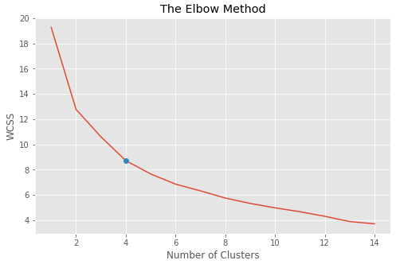

**Fig 2**: Scree plot showing the optimum number of clusters

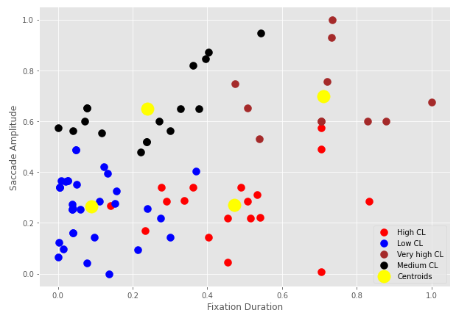

**Fig 3**: Scatter plot between Saccade amplitude and Fixation duration showing different clusters and their centroids

These 4 clusters are considered as channels. Very high CL cluster represents channel 1, Medium CL, and High CL represent Channel 2, and finally, Low CL represents channel 3 in the probabilistic neural network.

**Table 2**: Dependent Variable

|  |  |  |  |  |  |  |
| --- | --- | --- | --- | --- | --- | --- |
| **Cognitive Channel** | | **Eye movement Index** | | | | |
| **Avg Fixation frequency** | **Avg Fixation duration** | **Avg Saccade amplitude** | **Avg Saccade duration** | **Avg P** |
| **Single Channel** | **Visual** | 0.6706 | 0.7111 | 0.6986 | 0.8549 | 0.7614 |
| **Dual Channel** | **Visual- auditory** | 0.243 | 0.4714 | 0.2692 | 0.7882 | 0.8487 |
| **Visual - Tactile** | 0.3628 | 0.2389 | 0.6499 | 0.7818 | 0.5809 |
| **Three Channel** | **Visual - Tactile - Auditory** | 0.1328 | 0.0888 | 0.264 | 0.6878 | 0.6439 |

**Experimental Result**

The table below shows a small sample of normalized eye movement data from every channel.

**Table 3**: Normalized eye movement index data

|  |  |  |  |  |  |  |  |
| --- | --- | --- | --- | --- | --- | --- | --- |
| **Fixation Frequency** | **Fixation Duration** | **Saccade Amplitude** | **Saccade Duration** | **Performance** | **Channel** | **Subjective Load** | **Objective Load** |
| 0.5482 | 0.7338 | 1 | 1 | 0.625 | 1 | 0.9198 | 0.9 |
| 0.5245 | 0.7209 | 07568 | 0.8924 | 0.75 | 1 | 0.9665 | 1 |
| 0.8653 | 1 | 0.6745 | 0.8137 | 0.75 | 1 | 1 | 1 |
| 1 | 0.8776 | 0.5990 | 0.7835 | 0.75 | 1 | 0.9436 | 0.9 |
| 0.6933 | 0.8295 | 0.6000 | 0.8228 | 0.5 | 1 | 0.8372 | 0.8 |
| 0.2072 | 0.5419 | 0.2219 | 0.9330 | 0.875 | 2 | 0.6884 | 0.7 |
| 0.3572 | 0.8331 | 0.2860 | 0.9674 | 0.75 | 2 | 0.6839 | 0.7 |
| 0.3572 | 0.5072 | 0.2860 | 0.7669 | 0.75 | 2 | 0.6572 | 0.7 |
| 0.1533 | 0.7038 | 0.5736 | 0.8664 | 0.875 | 2 | 0.6979 | 0.7 |
| 0.1734 | 0.2341 | 0.1698 | 0.8528 | 0.875 | 2 | 0.5081 | 0.5 |
| 0.7846 | 0.2217 | 0.4783 | 0.7520 | 0.75 | 3 | 0.5893 | 0.6 |
| 0.5275 | 0.3782 | 0.6485 | 0.7869 | 0.875 | 3 | 0.7343 | 0.7 |
| 0.3855 | 0.4036 | 0.8712 | 0.8629 | 0.625 | 3 | 0.7558 | 0.8 |
| 0.0027 | 0.5433 | 0.9478 | 0.7928 | 0.625 | 3 | 0.5181 | 0.5 |
| 0.1455 | 0.3284 | 0.6484 | 0.8264 | 0.875 | 3 | 0.6134 | 0.6 |
| 0.3376 | 0.1115 | 0.2860 | 0.7268 | 0.625 | 4 | 0.4603 | 0.5 |
| 0.0376 | 0.2127 | 0.0939 | 0.8228 | 0.875 | 4 | 0.4007 | 0.4 |
| 0.0382 | 0.3703 | 0.4021 | 0.7166 | 0.5 | 4 | 0.3943 | 0.4 |
| 0.0114 | 0.0199 | 0.3615 | 0.8763 | 0.625 | 4 | 0.3910 | 0.4 |
| 0.0045 | 0.0143 | 0.0978 | 0.6511 | 0.5 | 4 | 0.1947 | 0.2 |

**Discussion**

**Correlation Between Eye Movement Parameters and CL of Users**

The CL estimated from an individual eye movement parameter cannot represent the mental load experienced by the users adequately. It is limited, biased, and often leads to misinterpretation of the mental state of users. Therefore, it is necessary to incorporate various types of eye movement index data for CL evaluation. More-importantly, the correlation between the CL and eye movement index data is analyzed.

In this study, for analysis of correlation between CL and eye movement index data Pearson correlation test was used. The test improved the theoretical understanding of the CL evaluation model. The result is shown in the table 4.

**Table 4**: Correlation between the CL and eye movement index parameter

|  |  |  |  |  |  |
| --- | --- | --- | --- | --- | --- |
| **Pearson correlation coefficient** | **Fixation frequency** | **Fixation Duration** | **Saccade Amplitude** | **Saccade Duration** | **P** |
| r | 0.705814 | 0.791895 | 0.589276 | 0.574104 | 0.396358 |

It can be observed from the table above that, each eye movement parameter is crucially correlated to the CL of users to a varying degree. It is once again demonstrated that the eye movement parameters are highly correlated to CL. Among all parameters, average eye fixation duration has highest correlation with the CL.

**Model Output Analysis**

Comparative analysis of subjective CL and Objective CL is shown in the graph below, and the degree of the fitting is high. It is observed that the CL from the model is quite similar to the actual CL values, which makes it very useful in practical life applications.

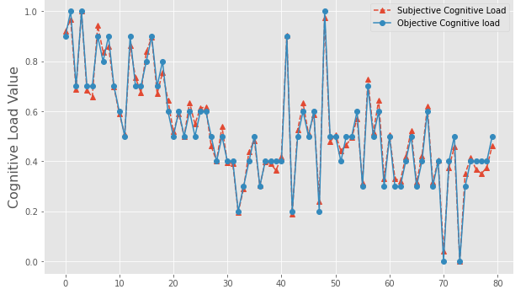

**Fig 4**: Comparison plot between subjective and objective CL values

The model accuracy is evaluated by the relative root mean square error and mean absolute error. The evaluation results are shown in the table below:

**Table 5**: Relative root mean square error and Maximum absolute error

|  |  |  |  |  |  |  |
| --- | --- | --- | --- | --- | --- | --- |
| Subjective Load | Objective Load | Absolute Error | Max Absolute Error | Mean Absolute Error | Relative MSE | Mean MSE |
| 0.9199 | 0.9 | 0.0216 | 0.0462 | 0.1111 | 0.1125 | 0.2336 |
| 0.9665 | 1 | 0.0346 |
|  |  |  |
| $$⋮$$ | $$⋮$$ | $$⋮$$ |
| 0.8372 | 0.8 | 0.0445 |
| 0.6884 | 0.7 | 0.0168 | 0.0892 | 0.1986 |
| 0.6839 | 0.7 | 0.0235 |
|  |  |  |
| $$⋮$$ | $$⋮$$ | $$⋮$$ |
| 0.5081 | 0.5 | 0.0160 |
| 0.5893 | 0.6 | 0.0180 | 0.1669 | 0.2461 |
| 0.7343 | 0.7 | 0.0467 |
|  |  |  |
| $$⋮$$ | $$⋮$$ | $$⋮$$ |
| 0.6134 | 0.6 | 0.0219 |
| 0.4603 | 0.5 | 0.0861 | 0.01426 | 0.3771 |
| 0.4007 | 0.4 | 0.0019 |
|  |  |  |
| $$⋮$$ | $$⋮$$ | $$⋮$$ |
| 0.1947 | 0.2 | 0.0271 |

For this study, the mean of maximum absolute error is 11.125% and the mean of relative root mean square error is 23.3615%. In individual channels, which are obtained from clustering, the minimum absolute error is 4.621%, the maximum absolute error is 16.698%, the minimum root mean square error is 11.253% and the maximum root mean square error is 37.714%. This shows that the Probabilistic Neural Network used in this study for CL evaluation has high precision and excellent reliability. The model can precisely evaluate the CL of a user under any type of mental workload condition. This can be helpful in better and ergonomic designing of Virtual Reality interface and improving experience of the user.

**Conclusions**

In the paper, various eye movement data were collected from a VR game system and used to study the effect of these parameters on CL. Here, the CL was calculated and quantified using the eye movement data. The conclusions are as follows:

Among various eye movement parameters, Fixation frequency, Fixation duration, Saccade amplitude, Saccade duration, and P are selected for probabilistic neural network modelling. The number of sensory channels used for each sample is found by clustering the dataset. Then, a probabilistic neural network is used to evaluate the CL experienced by the users.

The results of the study show that there is a high correlation between CL and eye movement variables. Especially, Fixation Duration and Fixation Frequency showed a correlation above 70% with the CL index. This shows that the CL experienced by a user is directly reflected from eye movement data, providing a theoretical basis for CL quantification.

It is also found out that the maximum absolute error of user CL based on PNN for all the channels lies between 4.62% - 16.69%, and the root mean square error lies between 11.25% - 37.71%. The average absolute error and Relative Root Mean Squared Error for the whole dataset is 5.75%, 12.524%, respectively, indicating that the method has high precision.

**Reference**

1. Jian Lv, Xiaoping Xu * and Ning Ding, Research on the Quantitative Method of Cognitive Loading in a Virtual Reality System, Guizhou University, Guiyang 550003, China; 2019
2. Mun, S.; Whang,M.; Park, S.; Park,M.C. Effects of mental workload on involuntary attention: A somatosensory ERP study. Neuropsychologia 2017, 106, 7–20.
3. Puma, S.; Matton, N.; Paubel, P.V.; Raufaste, É.; El-Yagoubi, R. Using theta and alpha band power to assess cognitive workload in multitasking environments. Int. J. Psychophysiol. 2018, 123, 111–120.
4. Yae, J.H.; Shin, J.G.; Woo, J.H.; Kim, S.H. A Review of Ergonomic Researches for Designing In-Vehicle Information Systems. J. Ergon. Soc. Korea 2017, 36, 499–523.
5. Mun, S.; Park, M.; Park, S.; Whang, M. SSVEP and ERP measurement of cognitive fatigue caused by stereoscopic 3D. Neurosci. Lett. 2012, 525, 89–94.[PubMed]
6. Mun, S.; Kim, E.; Park, M. Eﬀect of mental fatigue caused by mobile 3D viewing on selective attention: An ERP study. Int. J. Psychophysiol. 2014, 94, 373–381. [PubMed]
7. Yu, C.; Wang, E.M.; Li, WC; Braithwaite, G. Pilots' Visual Scan Patterns and Situation Awareness in Flight Operations. Aviat. Space Environ. Med. 2014, 85, 708–714.
8. Hogervorst, M.A.; Brouwer, A.; van Erp, J.B.E. Combining and comparing EEG, peripheral physiology and eye-related measures for the assessment of mental workload. Front. Neurosci. 2014, 8, 322.
9. Jimenez-Molina, A.; Retamal, C.; Lira, H. Using Psychophysiological Sensors to Assess Mental Workload during Web Browsing. Sensors 2018, 18, 458. [PubMed]
10. Sungchul, M. Overview of Understanding and Quantifying Cognitive Load. J. Ergon. Soc. Korea 2018, 37, 337–346.
11. Majooni, A.; Masood, M.; Akhavan, A. An eye-tracking study on the eﬀect of infographic structures on viewer’s comprehension and cognitive load. Inf. Vis. 2018, 17, 257–266.
12. Ooms, K.; Coltekin, A.; De Maeyer, P.; Dupont, L.; Fabrikant, S.; Incoul, A.; Kuhn, M.; Slabbinck, H.; Vansteenkiste, P.; Van der Haegen, L. Combining user logging with eyetracking for interactive and dynamic applications. Behav. Res. Methods 2015, 47, 977–993.
13. Hua, L.; Dong, W.; Chen, P.; Liu, H. Exploring diﬀerences of visual attention in pedestrian navigation when using 2D maps and 3D geo-browsers. Cartogr. Geogr. Inf. Sci. 2016, 44, 1–17.
14. Anagnostopoulos, V.; Havlena, M.; Kiefer, P.; Giannopoulos, I.; Schindler, K.; Raubal, M. Gaze-Informed location-based services. Int. J. Geogr. Inf. Sci. 2017, 31, 1770–1797.
15. Asan,O.;Yang,Y.UsingEyeTrackersforUsabilityEvaluationofHealthInformationTechnology: ASystematic Literature Review. JMIR Hum. Factors 2015, 2, e5.
16. Sassaroli, A.; Zheng, F.; Hirshﬁeld, L.M.; Girouard, A.; Solovey, E.T.; Jacob, R.J.K.; Fantini, S. Discrimination of Mental Workload Levels in Human Subjects with Functional Near-infrared Spectroscopy. J. Innov. Opt. Health Sci. 2008, 1, 227–237.
17. Herﬀ, C.; Heger, D.; Fortmann, O.; Hennrich, J.; Putze, F.; Schultz, T. Mental workload during n-back task-quantiﬁed in the prefrontal cortex using fNIRS. Front. Hum. Neurosci. 2014, 7, 935.
18. Wilson, G.F.; Russell, C.A. Real-time assessment of mental workload using psychophysiological measures and artiﬁcial neural networks. Hum. Factors 2003, 45, 635–643.
19. Mueller, K.; Tangermann, M.; Dornhege, G.; Krauledat, M.; Curio, G.; Blankertz, B. Machine learning for real-time single-trial EEG-analysis: From brain-computer interfacing to mental state monitoring. J. Neurosci. Methods 2008, 167, 82–90.
20. Noel, J.B.; Bauer, K.W., Jr.; Lanning, J.W. Improving pilot mental workload classiﬁcation through feature exploitation and combination: A feasibility study. Comput. Oper. Res. 2005, 32, 2713–2730.
21. Oh, H.; Hatﬁeld, B.D.; Jaquess, K.J.; Lo, L.-C.; Tan, Y.Y.; Prevost, M.C.; Mohler, J.M.; Postlethwaite, H.; Rietschel, J.C.; Miller, M.W.; et al. A Composite Cognitive Workload Assessment System in Pilots Under Various Task Demands Using Ensemble Learning. In Proceedings of the AC 2015: Foundations of Augmented Cognition, Los Angeles, CA, USA, 2–7 August 2015.
22. Lu, L.; Tian, F.; Dai, G.; Wang, H. A Study of the Multimodal Cognition and Interaction Based on Touch, Audition and Vision. J. Comput.-Aided Des. Comput. Graph. 2014, 26, 654–661.
23. Zhang, G.H.; Lao, S.Y.; Ling, Y.X.; Ye, T. Research on Multiple and Multimodal Interaction in C2. J. Natl. Univ. Def. Technol. 2010, 32, 153–159.
24. Wei, L.; Yufen, C. Cartography Eye Movements Study and the Experimental Parameters Analysis. Bull. Surv. Mapp. 2012, 10, 16–20.